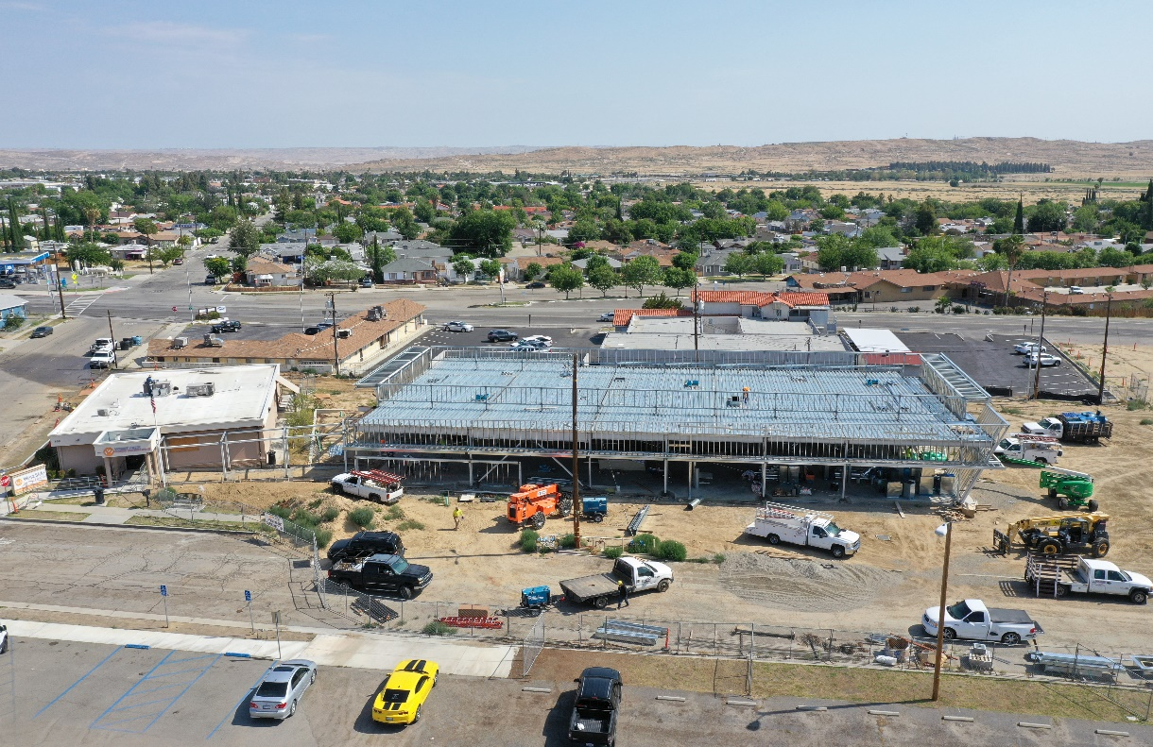 |  | -

Annual Report
2019

A Message from the President of the Board, Eric Cooper
What a privilege your Board has to serve the communities of our West Side Health Care District! We are local citizens serving as Board members whose mission is to create and maintain the resources to meet the health care needs of the patients and families of the Westside. The legacy of Board members from our community serving the West Side Hospital and West Side Health Care District Boards dates back to 1947.
As our current Board members continue that legacy of meeting the challenges--in a changing health care industry--we continue on the exciting journey we began in 2018 to expand the capacity of the West Side Family Health Care Clinic. The Clinic expansion project is well under way and expected to be operational in the fall of this year. With the additional Clinical space available your Board continues with the plan to offer additional medical services in the near future.
The Health Care District Board, District Staff, and the providers and staff of West Side Family Health Care Clinic respect and appreciate the support of our community! Our commitment to a stronger future of health and wellness services to the families and patients that we serve remains strong.

A Message from the Executive Director, Gerald Starr
Our Annual report for 2018 noted the goal of an addition of 12,810 square feet of clinical space to the existing Clinic. The Site development for a modern Clinic with 9 examination and 3 treatment rooms began on August 14, 2018. The $9.3 million dollar facility project construction in progress is about 50% complete and is expected to be completed and operational in the fall of 2019.
We have several short-term goals. The first of which is, of course, to bring the new Clinic space into full operation. Another short-term goal is to recruit a second full-time Board Certified Family Medicine physician to the Westside. This will continue the development of our Primary Care mission to the patients, families and citizens of the West Side Health Care District. We will continue our Walk-in clinic services during the Clinic’s 88 hours of operations, 7 days a week.
We will continue to evaluate other health services in support of--or in collaboration with--other health care providers. Our long-term goal is to develop a sustainable level of health care services on our Health Care Campus at a financially feasible cost to the tax payers of the District.
We continue with our goal to establish dental services in the existing Clinic when the new Primary Care and Walk-in Clinic space is operational. Our Radiology Services to our patients and the patients of other providers will continue.
In all of our change---Clinic structure, training, planning and new programs—I continue to acknowledge the commitment and dedication of our Clinic staff: The physicians, nurse practitioners and their Clinic support team members continue to do a tremendous job!
Patient healthcare is our Mission. The leadership of the Board of Directors and the hard work of the District Office staff will continue to meet the challenges of providing healthcare in a rural setting. We appreciate the support of the citizens of the communities of the West Side Health Care District. We will strive to earn the trust and respect of our patients and their families.

A message from the Medical Director, Ronald J. Ostrom, D.O.

I am now entering my second year as the Medical Director for the West Side Health Care District and West Side Family Health Care Rural Health Clinic and I am excited about the positive influence and changes I have been able to elicit in my role at the Clinic. We continue to meet our objective to offer the best possible primary care services as well as acute care and walk-in services for our patients.
In reviewing our previous goals, we continue to work towards and effectively achieve our mission of improving the health outcomes of our patients. Since starting at the District, we have successfully recruited a full time Family Practice Physician and two Nurse Practitioners to help us meet this goal.. These hires have provided more consistent provider scheduling and have enabled our Clinic to reduce our dependency on temporary providers. This has significantly improved the health care services our patients are receiving.
Our efforts will continue to focus on expanding access to primary care services through the expansion of the Clinic. We will also continue to evaluate offering select specialty services through face-to-face encounters and growing specialty services through telemedicine.. We understand greater access to these services are important to the patients we serve due to their limited resources and transportation issues.
.
Community involvement remains an integral component of our mission. We are proud of our involvement at the West Side Rotary Health Fair and student health physical events at Taft Union High School and the Recreation and Parks District. In addition, I and others will offer medical services for the Taft High School Football team. My involvement in concussion management and education for all of Kern County High School District’s coaches, athletic directors and athletic trainers for the last decade will help improve the standard of care on the sideline and help keep our student athletes safe. Our medical team looks forward to strengthening our relationship with the community in the years to come.

We are excited about the steps West Side Family Health Care is taking to expand health care services on the West Side as we raise the standard of care for our patients. We will continue to move toward our goal of being the leader in quality healthcare for the West Side communities.

Our History
The West Side Hospital District was created in 1947 and operated the West Side District Hospital in Taft from 1952 until 1998. The District sold the Hospital to Catholic Healthcare West (CHW) in 1998. In 2003 CHW closed the Mercy Westside Hospital. In another location the District opened a small urgent care clinic in 2004.
On December 22, 2008, the District purchased the closed Hospital property from CHW which included a separate outpatient clinic. The District initiated some renovations and modifications and the facility opened in March of 2010 as West Side Urgent Care. The expanded Urgent Care included Digital radiology and Clinical Laboratory services.
In 2015 the District Board made the strategic decision to address the need for improved/enhanced access to primary care for the citizens and communities of the West Side Health Care District. A plan was set in motion to convert the Urgent Care Clinic to a federally certified Rural Health Clinic. That goal was achieved with CMS certification of the West Side Family Health Care Clinic effective January 12, 2017.
Two full-time Board Certified primary care physician are the core of our medical staff along with a stable schedule of per diem physicians which enables the expanded access to daily health services 365 days a year. We offer two excellent mid-level Nurse Practitioners for 50% or more of our Clinic operating hours. We continue our telemedicine services. The Clinic is a provider for the Vaccine for Children (VFC) and will become a provider for the Children’s Health and Development Program (CHDP).
The District has begun construction of a $9,000,000 Outpatient Clinic expansion project of approximately 12,800 square feet. The new space will include additional treatment space(s) and separate adult and pediatric clinics plus operational support space. The project anticipates a $5,300,000 equity contribution by the District and a $4,000,000 grant from an anonymous donor. The West Side Health Care Foundation is active in supporting the grant and additional fund raising directly through the Foundation Board’s fund raising activities.

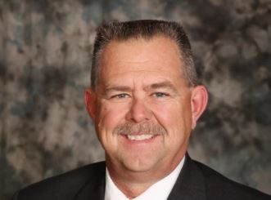
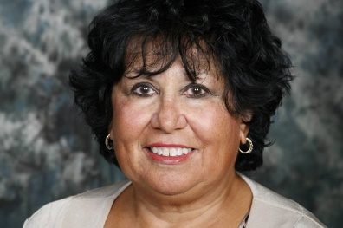
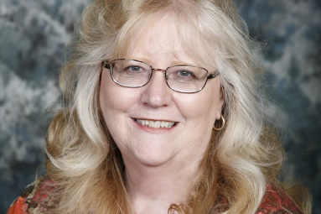
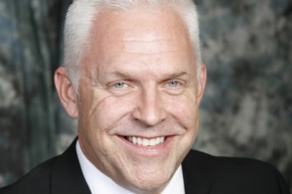
“As a rural health care district dedicated to the healing arts, we are committed to meeting the challenges of the future by preserving quality health care services for the needs of the Westside community we serve.”

Our Mission Statement
Darren Walrath
Board Member

Janice Ashley
Board Member
Virginia Miller
Secretary
Adele Ward
Vice President
Eric Cooper
President
Board Meetings

Board meetings are held on the 4th Thursday of each month at 2:00pm.
Located at the West Side Health Care District Office
119 Adkisson Way • Taft, CA 93268
_____________________
Regular meetings of the board are open to the public.
Agendas are posted 72 hours in advance of meetings.
(WSHCD Admin Office • WSHCD Website)
Contact the administrative office for additional information or special needs assistance.
____________________

Our Structure

Board of Directors
In the chart below, each committee is outlined. Each committee meets separately on an as needed basis. Each committee presents a verbal report of the committee’s functions at the monthly schedule Board meeting.

Board Committees
Janice Ashley
Adele Ward
Darren Walrath
Janice Ashley
Eric Cooper
Darren Walrath
Eric Cooper
Virginia Miller
Personnel Committee
Community Outreach
Facilities Committee
Finance Committee

Our Providers

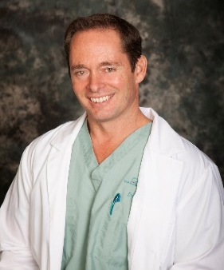
Ronald J. Ostrom, D.O.
Medical Director

Dr. Ronald Ostrom is an Emergency Medicine physician in the county of kern. He is affiliated with multiple hospitals in the area, including Bakersfield Heart Hospital, Mercy Hospitals of Bakersfield, as well as the Medical Director for Hall Ambulance. Dr. Ostrom received his medical degree from the College of Osteopathic Medicine of the Pacific and has been in practice for 20 years. He is one of seven providers, as well as the Medical Director of the West Side Family Health Care Facility. Dr. Ostrom resides in Bakersfield with his wife and two children.

Dina Villanueva, D.O.
Dr. Dina Villanueva is a family practice physician who has worked for West Side Health Care District since November 2018. Dr. Villanueva has been a physician for almost 30 years, since she graduated from the Western University of Health Sciences in Pomona, CA. She has worked most of her career in underserved areas, namely with the Alaskan Natives under the Indian Health Service (IHS) in Barrow & Wrangell, Alaska; the inmates in the California Department of Corrections & Rehabilitation (CDCR) in Central, CA; and numerous Federally Qualified Health Care (FQHC) facilities in Central & Southern, CA. She is happy to now work in Taft, CA for the Federally Qualified Healthcare (FQHC) facility operated by West Side Health Care District because there is such a need for a primary care physician in such an underserved area. She is open and willing to share what she knows about traditional and alternative medicine to all patients that can receive any benefit from her decades of experience.

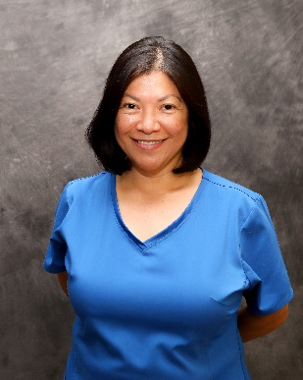

Heather Bosma, MSN, RN, PHN, FNP-C

Heather Bosma graduated with her Bachelor of Science in Nursing from Fresno State in 2005, and began her career as a pediatric nurse at Valley Children’s Hospital in Madera, California and later at Cottage Children’s Hospital in Santa Barbara, California. She continued her education and obtained a Master of Science in Nursing and School Nurse Credential from California State University of Bakersfield in 2010. Heather worked as the school nurse for Taft City Schools and Taft High School from 2008-2012. In 2013 she attended Western University of Health Sciences and received her Family Nurse Practitioner Certificate. Heather is dedicated to providing comprehensive healthcare, and encouraging health promotion in individuals and the community. On her days off she enjoys spending time with her family, being outdoors, and cooking.

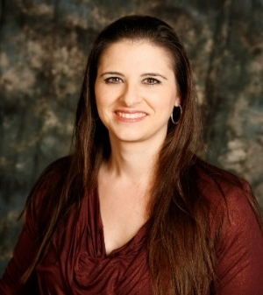

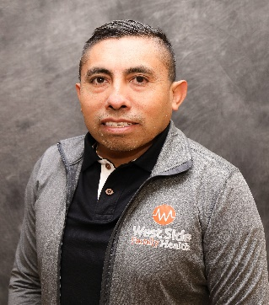
Abundio Castillo, MSN, RN, PHN, FNP-C

Abundio Castillo was born in Mexico and moved to the United States of America in 1993. When he came to USA, he did not speak English, therefore, he went to adult school and then enrolled at Santa Barbara City College. In Mexico, he studied Business administration, but always wanted to work in the medical field. In Santa Barbara City College, he met a wonderful mentor that was a nurse, and she guided him to get his LVN and RN license. During his career as RN he held many positions from staff nurse to director and manager of the emergency room at dignity hospitals in Bakersfield. Abundio moved to Bakersfield about 13 years ago, and has been working to serve the Kern County community and he found out that a lot of people lacks the medical care attention, therefore, to better serve our community, he went back to school to become a Family Nurse Practitioner. He graduated in 2018 from Charles R. Drew University School of Medicine and Science. Since then, and has been working at Memorial Hospital ER, Priority Urgent Care and currently at West side Family Health Care Clinic in Taft. Abundio is bilingual in Spanish and English. He feels much rewarded to be able to help our Kern county community. Abundio is happily married and has 4 children.

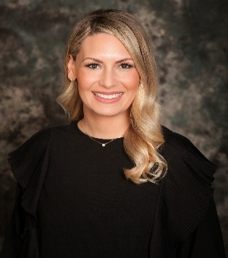
Elizabeth White, MSN, RN, FNP-C

Beth is a Family Nurse Practitioner and Board Certified by the American Association of Nurse Practitioners Born and raised in Bakersfield, CA; she began her nursing career in 2011, working as a Registered Nurse in the Intensive Care Unit. Beth holds both a Bachelor’s Degree and Master’s Degree in Nursing from California State University, Bakersfield.
Beth is dedicated to serving the residents of West Kern County. She is qualified to diagnose and treat a wide array of conditions across the entire lifespan and believes in working collaboratively with each individual to achieve their best possible state of health.

∗ In addition to full time providers, our medical staff includes per diem providers who are trained in a variety of disciplines such as Internal Medicine, Emergency Medicine, and Family Practice.
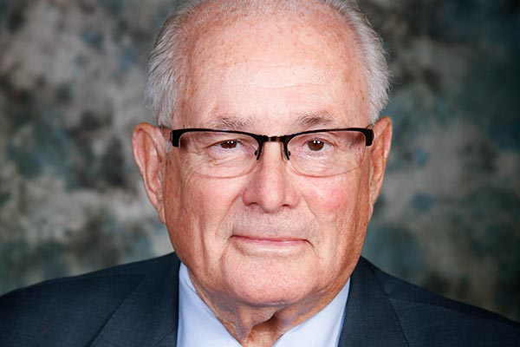

District Leadership

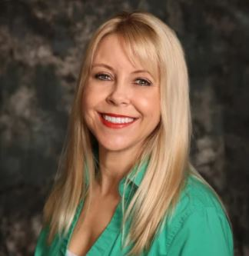
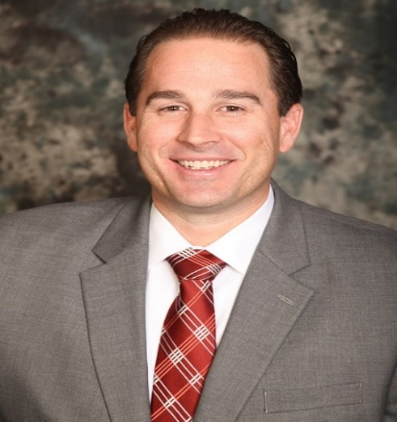
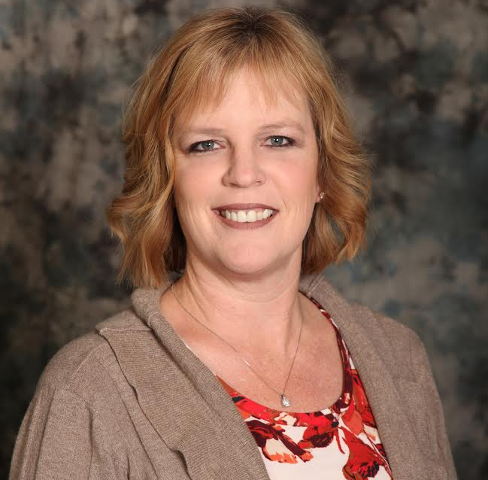
Summer Wood-Luper, Clinic Director, BSN, PHN

Raised in the Pacific Northwest, Summer has a true love of nature, enjoying exercise, outdoor activities, and community events. After meeting her husband and completing her Associate in Arts degree at Taft College, she went on to pursue her Bachelor of Science in Nursing and Public Health Nursing License at California State University Bakersfield in 2008. Now married with two children, Summer has chosen to make Taft her home and has resided here since 2002. She is committed to helping her community members attain the highest level of health and wellness through her role as Clinic Director.

Ryan Shultz, Director of Clinical Operations
Ryan was born and raised in Bakersfield, CA, and graduated from Westmont College with a degree in Political Science. Ryan earned his Masters of Science in Health Care Administration from California State University Bakersfield. He is also a graduate of the Kern Leadership Academy. Previously, Ryan served the Westside as staff to Kern County’s Fourth District Supervisor. As a part of his graduate studies, Ryan’s thesis analyzed best practices for a Rural Health Clinic. As Director of Clinical Operations his duties include oversight and management of the Clinic’s operations and the District’s revenue cycle. Ryan is married to Brittany and together they have two children Emery and Everett.
E-mail Ryan at rshultz@wshcd.org
Robyn Melton, District Manager

Born in Taft, and a lifelong resident of the Westside, Robyn is proud to be part of such a great community. An active member of the Taft Kiwanis club, she loves participating in community service. She also serves as a Board member for the West Side Cemetery District. Robyn has been employed with the District since April 2008 and serves as Clerk of the Board. She is responsible for overseeing all of the day to day operations of the District, as well as handling many HR-related activities. She looks forward to all the wonderful progress and growth in store for the Taft Community. Robyn enjoys camping and traveling with her family. She is married to her husband Steven, they have three grown children.

Gerald A. Starr, District Office Executive Director, MPH, FACHE

Gerald (Jerry) was born in Jerome, AZ. Jerry graduated from the University of Oklahoma with a degree in Business Administration and received a commission as a Second Lieutenant in the Medical Service Corps. Jerry later earned his Masters of Public Health degree from Yale University. Jerry left the Air Force with the rank of Major with over 23 years of active service. Jerry’s has served Kern County for over 30 years in CEO, COO and Vice President Positions at Bakersfield Memorial Hospital, Kern Medical Center, Mercy Hospital and Delano Regional Medical Center. Jerry is married to Robin. He is a Charter Member and Past President of the Rotary Club of Bakersfield Breakfast. Jerry also enjoys volunteer work in his Church, as a CASA Advocate, and serving at the Guild House in support of the Henrietta Weill Memorial Child Guidance Clinic.

Health Services

Family Practice • Pediatrics • Urgent Care • X-Ray Services • Workers Comp

Patients Served: Fiscal Year 2019 (July 1st 2018-June 30, 2019)

Visit Type | Census | Patient Lives
Adult | 9,622 | 4,382
Pediatrics | 6,862 | 2,953

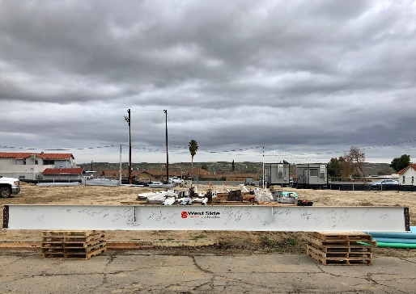
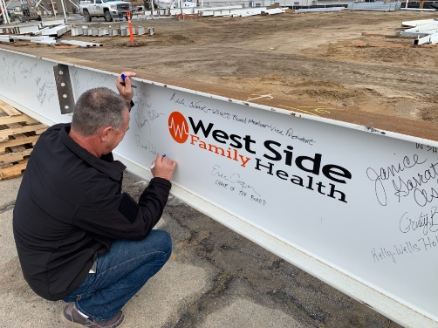
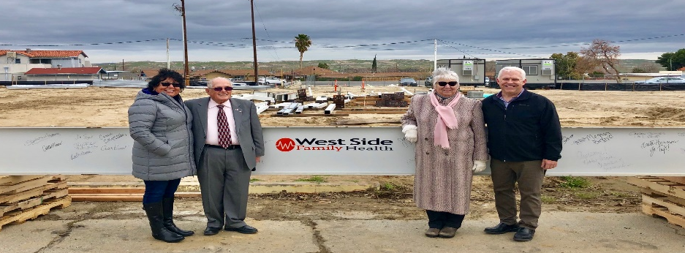
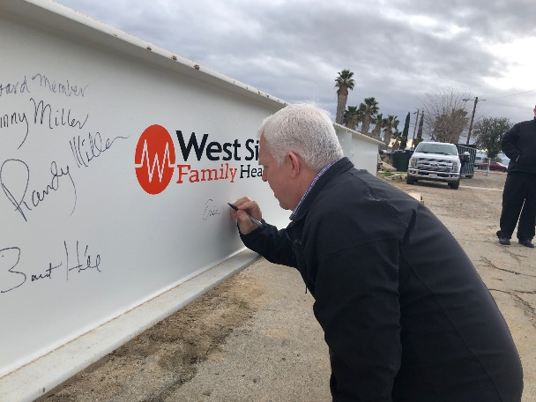
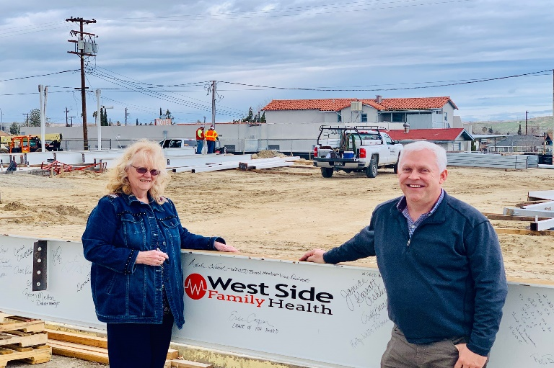
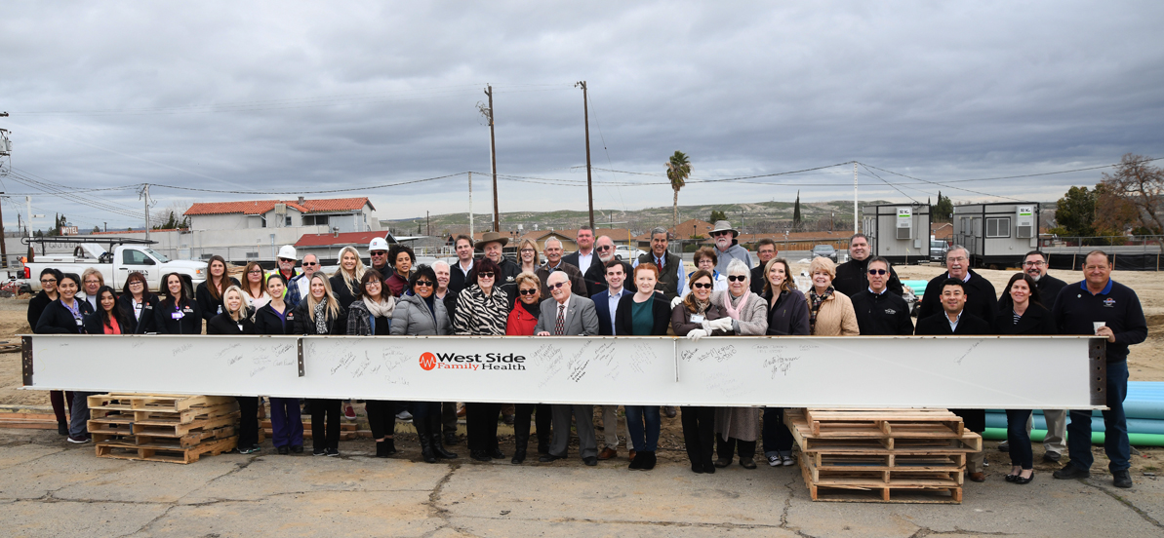
`

The West Side Health Care District celebrated the new outpatient clinic on Friday, July 13th, 2018.

The ceremony marked a new beginning and another step to rebuilding the community’s health care infrastructure.

“This is a symbol of a new beginning for us,” Health Care District Board President Eric Cooper said.
Topping Off Ceremony
February 20th, 2019

Community Outreach
Taking immense pride in our youth and community, the District and Board members are dedicated to supporting a wide variety of community and charitable activities.

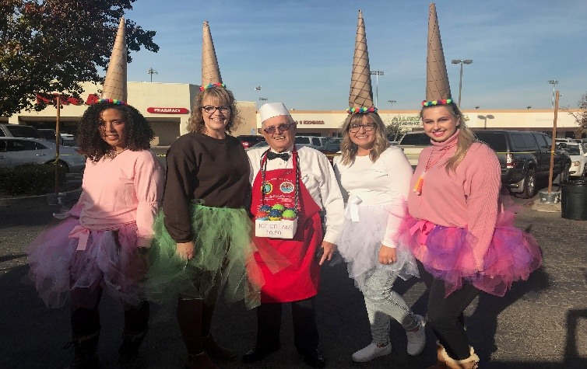
Halloween Spooktacular

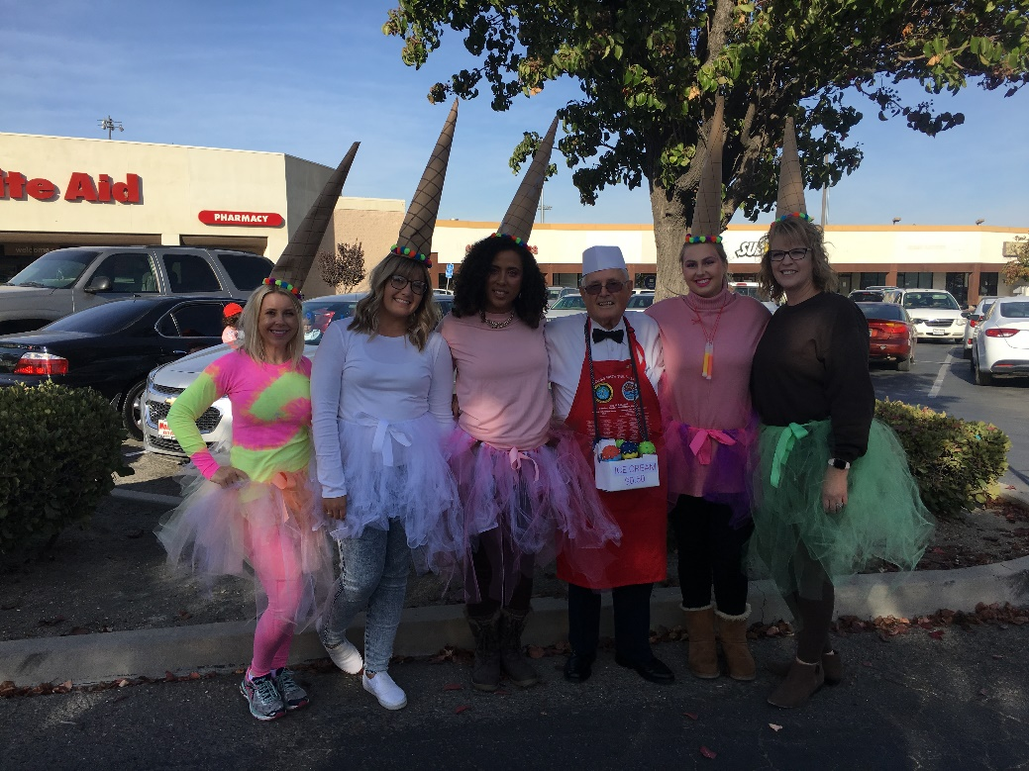

The District had the opportunity to participate in the community Spooktacular event on Halloween.
The event was well attended and there was always a line for our ice cream truck inspired Bean Bag Toss.

Left to Right: Summer Wood-Luper, Emily Jackson, Carrie Coleman, Jerry Starr, Meghan Bravo, Robyn Melton

Career Day Events

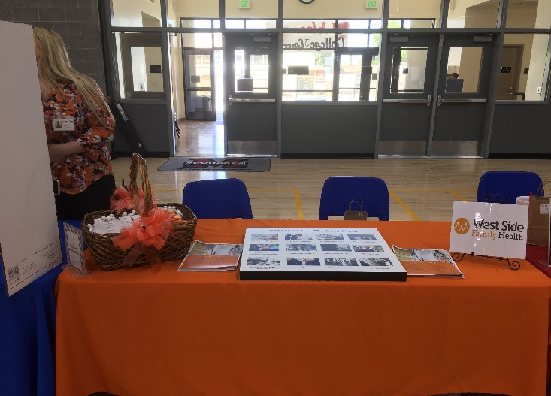
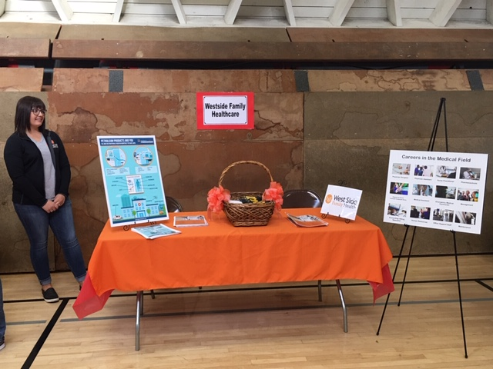

Lincoln Elementary School
Maricopa Unified School
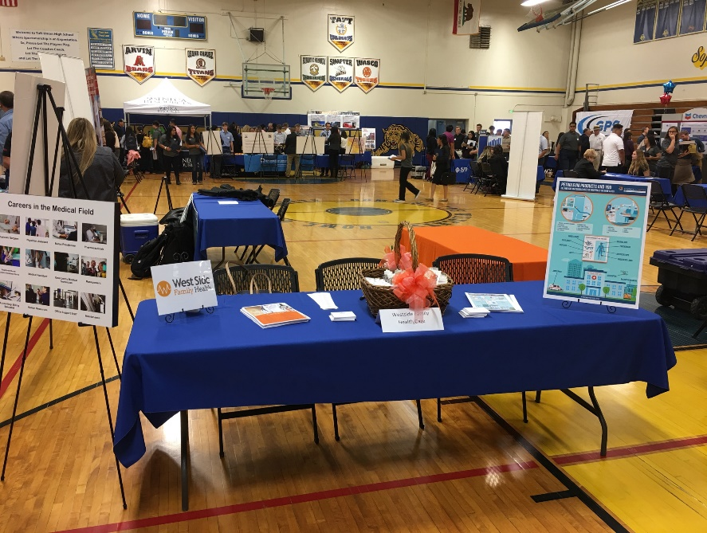

Taft Union High School

Sports Physicals, 2019

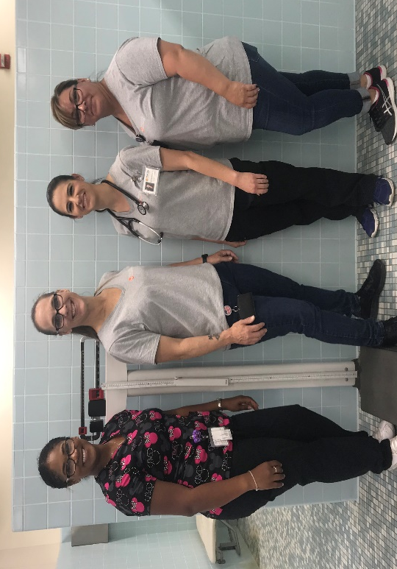

West Side Family Health Care looks forward to supporting the community by taking part in performing the West Side Recreation and Park and Taft Union High School Sports Physicals. This year our staff completed 86 physicals.

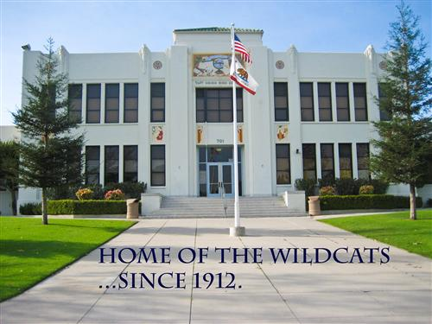

Starting the school year off with a bang, we were given a great opportunity to be a part of preparing our TUHS athletes for the upcoming sports season. We were able to perform physicals in two days! Go Wildcats!!

.

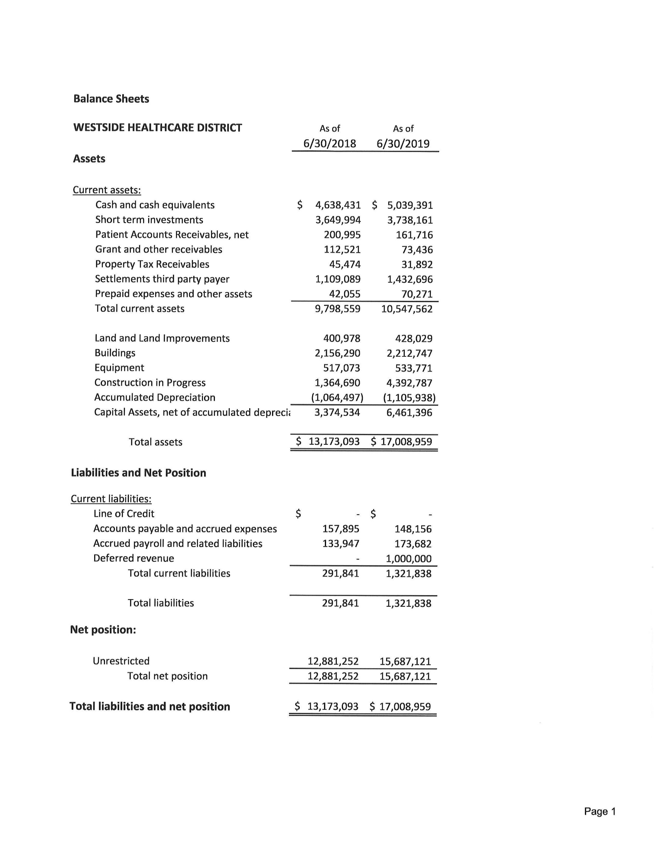
West Side Health Care District

Statements of Revenues, Expenses and Changes in Net Position
West Side Health Care District

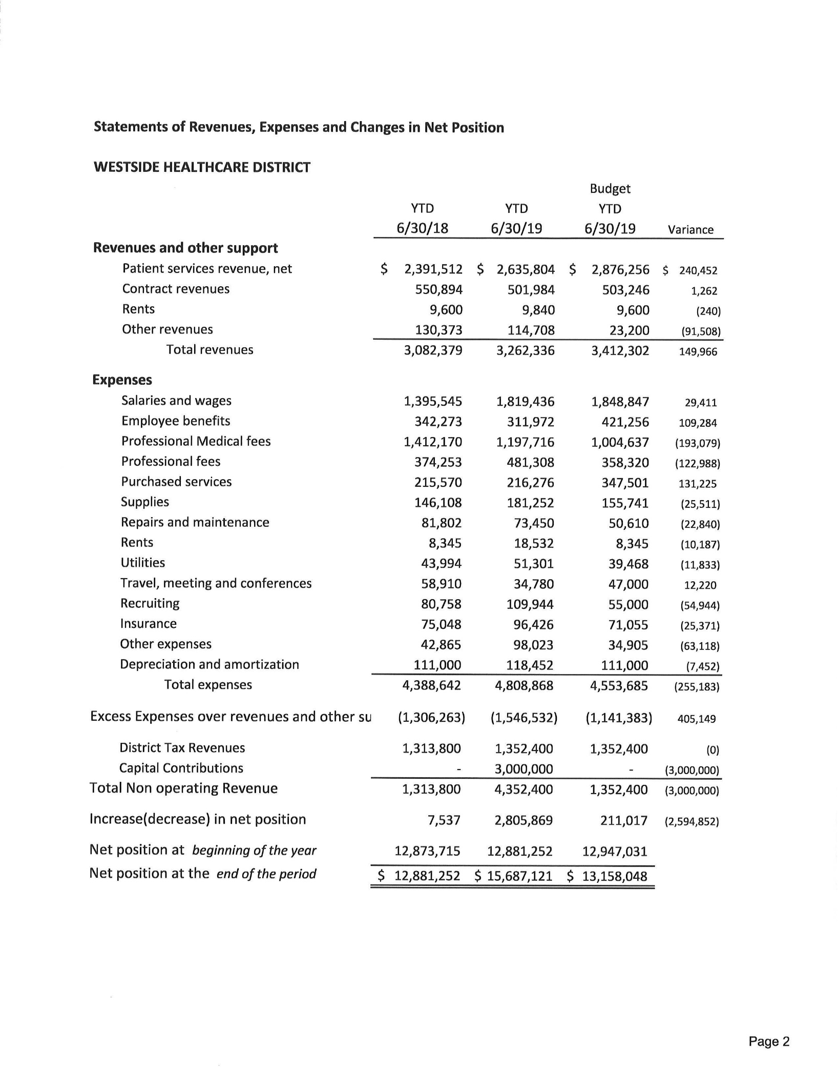
District Tax Revenues: The District receives much of its financial support from parcel taxes. These funds are used to support operations and meet required debt service agreements. They are classified as non-operating revenue as the revenue is not directly linked to patient care. Parcel taxes are levied by the County on the District’s behalf during the year, and are intended to help finance the District’s activities during the same year. The County has established certain dates to levy, lien, mail bills, and receive payments from property owners during the year. Parcel taxes are considered delinquent on the day following each payment due date.

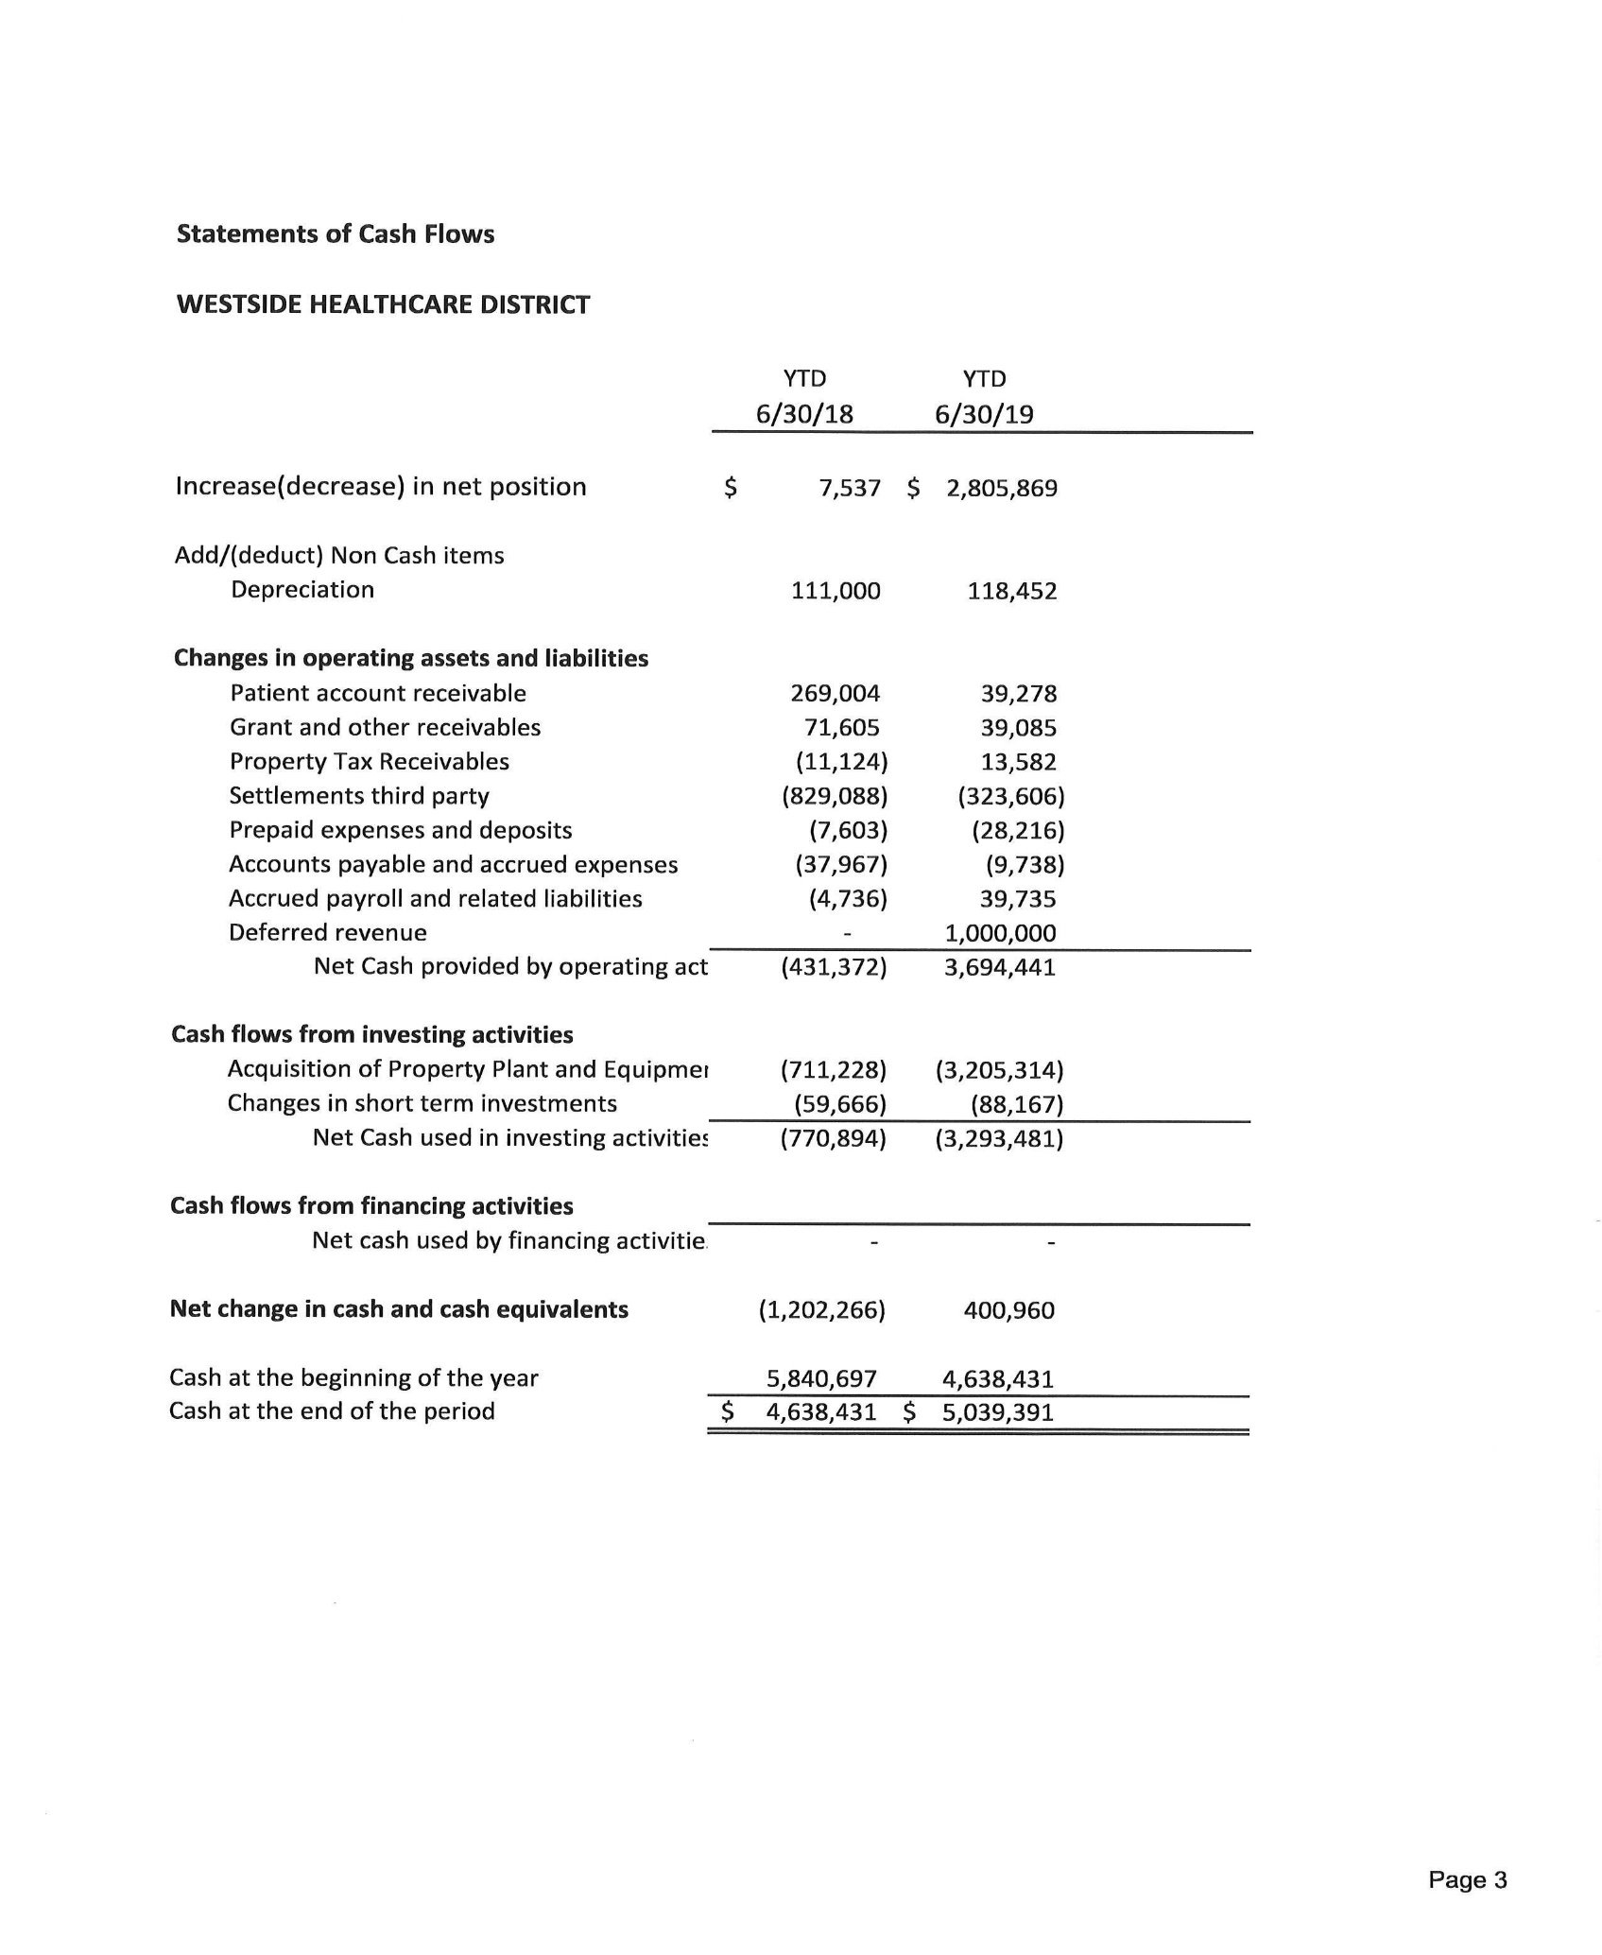
West Side Health Care District

Budget 2019/2020
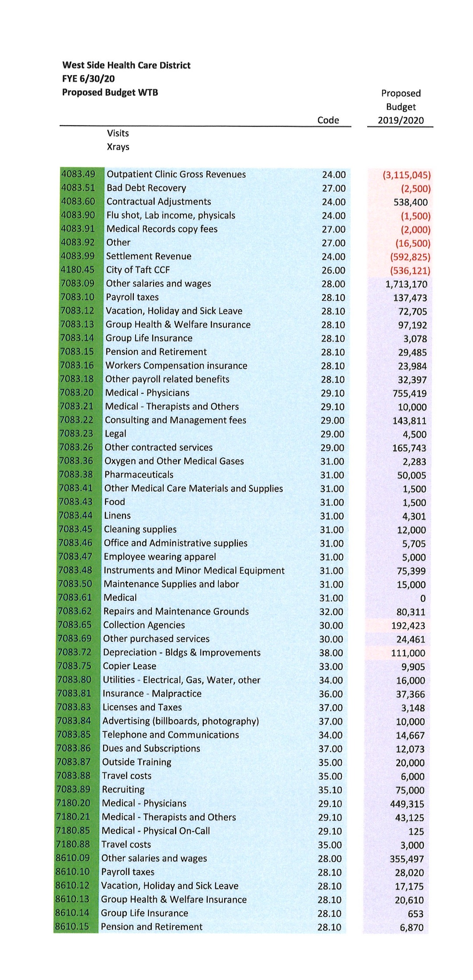
West Side Health Care District

.

Budget 2019/2020
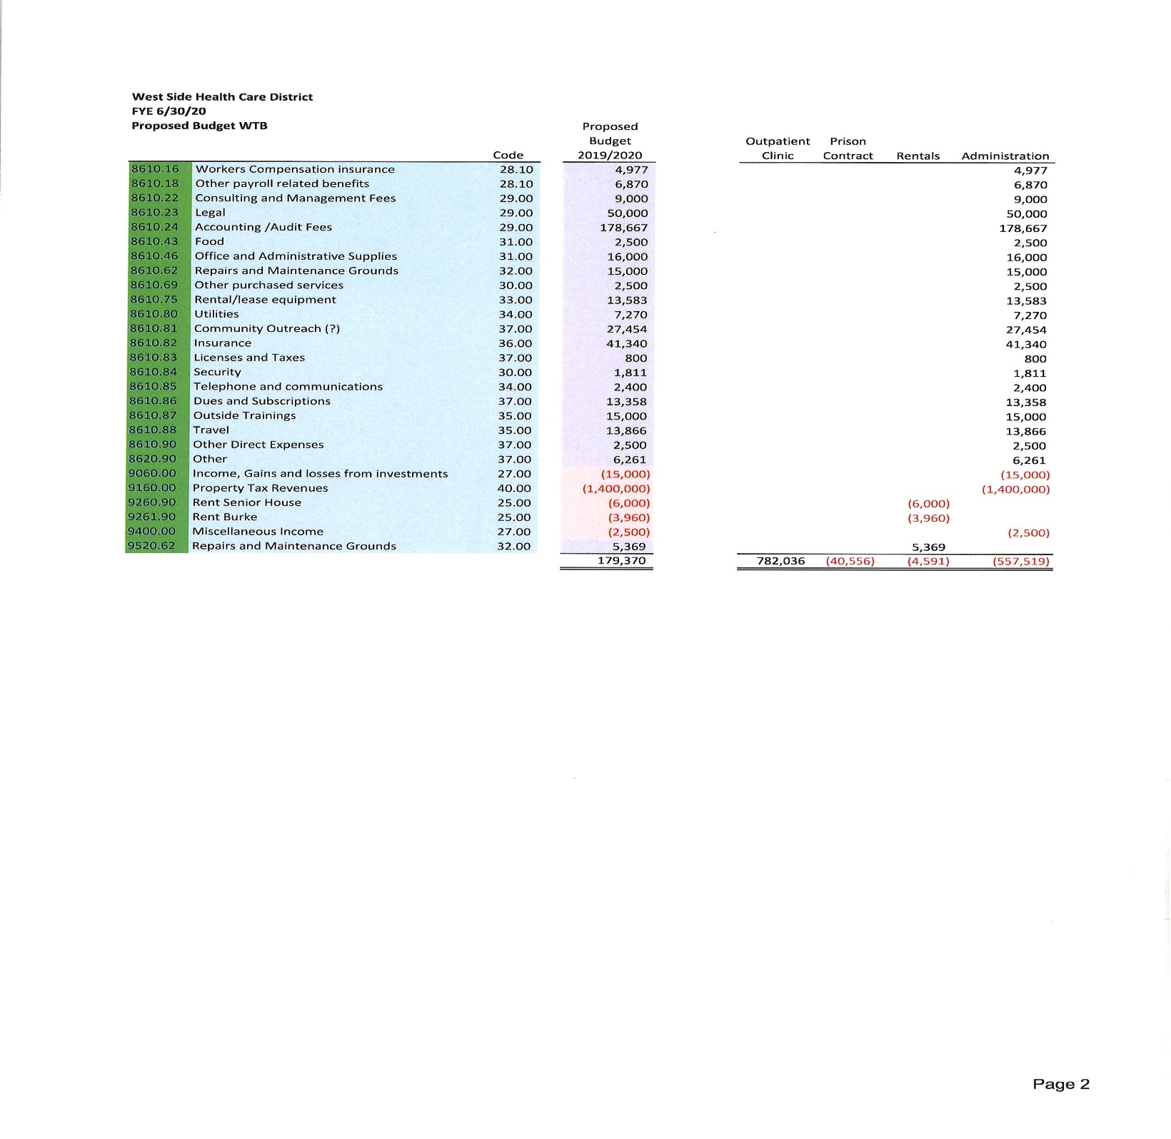
West Side Health Care District

Directory

Name | Title | Email | Phone Number
Gerald Starr | Executive Director | gstarr@wshcd.org | Office: 661-765-7234  Direct Line: 661-745-4924
Ryan Shultz | Director of Clinical Operations | rshultz@wshcd.org | Office: 661-765-7234  Ext. 209
Ronald J. Ostrom, D.O. | Medical Director | rostrom@wshcd.org | Office: 661-765-1935
Summer Wood-Luper | Clinic Director | swoodluper@wshcd.org | Office: 661-765-1935  Ext. 123
Robyn Melton | District Manager | rmelton@wshcd.org | Office: 661-765-7234  Ext. 201

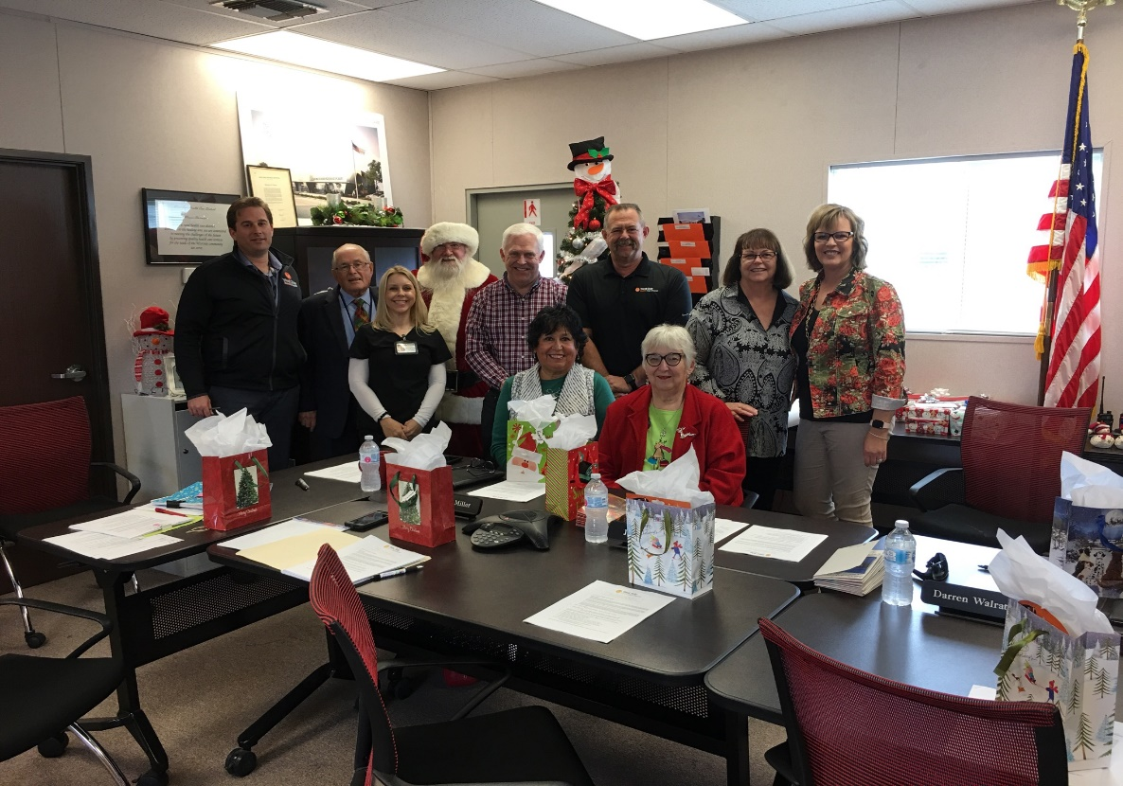
West Side Health Care district

West Side Family Health Care
Mailing Address:
100 E. North Street
Taft, CA 93268

Phone: 661-765-1935
Fax: 661-765-1928

Clinic Hours:
Monday-Friday
8:00am-9:00pm

Saturday, Sunday, & Holidays
10:00am-9:00pm

Website: www.wshcd.org

District Office

Mailing Address:
119 Adkisson Way
Taft, CA 93268

Phone: 661-765-7234
Fax: 661-765-7284

District Office Hours:
Monday-Friday
8:00am-5:00pm

Website: www.wshcd.org

