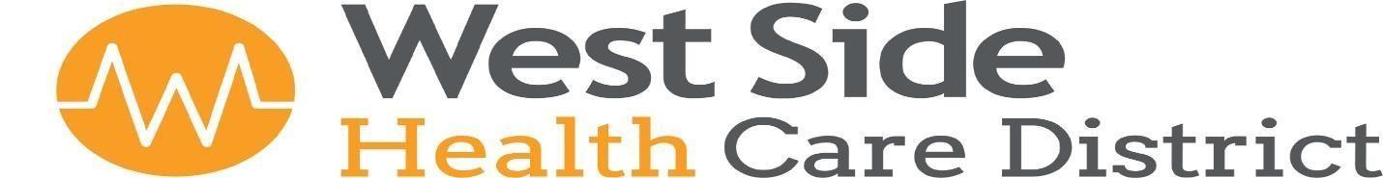

115 Adkisson Way Taft, CA 93268 (661) 765 - 7234

Board Meeting Agenda
Thursday, April 23, 2026 at 2:00pm

This Meeting will be held via Zoom for some participants.
To participate in the meeting call: 1 (253) 215-8782 Meeting ID: 906 534 8742 Password: 957815

1. Call to Order
Pledge of Allegiance
Approval of Agenda

2. Public Input
This is the time for public comment. Members of the public may be heard on any item on the agenda. A person addressing the Board will be limited to five minutes unless the Chairperson grants a longer period of time. Comments by members of the public on an item on the agenda will only be allowed during consideration of the item by the Board. When the item is called, please raise your hand or stand if you desire to address the Board.

Members of the public may also, at this time only, address the Board on any non-agenda items, your comments will be limited to five minutes. You should raise your hand or stand at this time. Although Board Members may ask questions for clarification, the Board will not debate issues with the speaker. Non-emergency items may be rescheduled for a discussion at a later date. Please note, the Board may take action on non-agenda items only in emergency circumstances.

After the comments, the public is allowed to remain and listen or may leave at any time.

AMERICANS WITH DISABILITIES ACT (Government Code Section 54943.2) The West Side Health Care District is accessible to persons with disabilities. Disabled individuals who need special assistance to attend or participate in a meeting of the West Side Health Care District may request assistance at 115 Adkisson Way Taft, California, or by calling (661) 765-7234. Reasonable effort will be made to accommodate individuals with disabilities by making meeting materials available in alternative formats. Requests for assistance should be made five (5) working days in advance of a meeting whenever possible.

3. Approval of Minutes
Board Meeting Minutes – Thursday, March 26, 2026
Facilities Committee Meeting – Tuesday, April 7, 2026

4. Financial Review
A. District CPA, Kelly Hohenbrink, will join the meeting via Zoom. Review and Discussion- Receive
and File the Unaudited March 2026 Financial Reports.

5. Annual Review and Approval of Policy and Procedures
A. West Side Family Health Care - Miscellaneous Policies
B. West Side Health Care District - Miscellaneous Policies

West Side Health Care District
Board Meeting Agenda
Thursday, April 23, 2026 Page 2 of 2

6. Potential Awards of Public Works Contracts
A. Award of public project to MQS Construction for exterior stucco and paint (including
materials and work) in the amount of $72,000.00 for 109 Adkisson Way, Taft, CA,
pursuant to Board Resolution 2025-1 and CA Public Contract section 22030 et seq.

B. Award of public project to Bakersfield Paving for parking lot asphalt (including
materials and work) in the amount of $68,384.00 for 109 Adkisson Way, Taft, CA,
pursuant to Board Resolution 2025-1 and CA Public Contract section 22030 et seq.

C. Award of public project to MQS Construction for roof replacement (including
materials and work) $55,000.00 at 109 Adkisson Way, Taft, CA, pursuant to Board
Resolution 2025-1 and CA Public Contract section 22030 et seq.

7. Administrative Staff Reports
A. April 2026 General Information- Attached for informational purposes only.
B. Portable X-Ray Machine Demonstration, Radiology Supervisor, Michele Shelton, Dr. Ostrom
and Summer Wood Luper.

8. Committee Updates
- Finance Committee
Eric Cooper or Ginny Miller
- Facilities Committee
Eric Cooper or Darren Walrath
- Community Outreach
Jan Ashley or Darren Walrath
- Personnel Committee
Adele Ward or Jan Ashley
- Additional Board Member Input
This Portion of the meeting is reserved for Board Members to present information, announcements, or other items that have come to their
attention. A Board member may request that an item is placed on the agenda for consideration at a future meeting or refer an item to the
Executive Director for a formal report. The Board will take no formal action at this time.

9. Items for Future Agendas

10. Adjournment

The next Board Meeting is Scheduled for Thursday, May 28, 2025 at 2:00 pm

