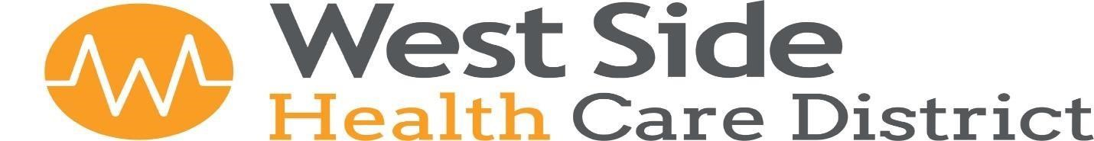

115 Adkisson Way Taft, CA 93268 (661) 765 - 7234

Board Meeting Agenda
Thursday, December 18, 2025 at 4:00pm

This Meeting will be held via Zoom for some participants.
To participate in the meeting call: 1 (253) 215-8782 Meeting ID: 906 534 8742 Password: 957815

- Call to Order
Pledge of Allegiance
Approval of Agenda

2. Public Input
This is the time for public comment. Members of the public may be heard on any item on the agenda. A person addressing the Board will be limited to five minutes unless the Chairperson grants a longer period of time. Comments by members of the public on an item on the agenda will only be allowed during consideration of the item by the Board. When the item is called, please raise your hand or stand if you desire to address the Board.

Members of the public may also, at this time only, address the Board on any non-agenda items, your comments will be limited to five minutes. You should raise your hand or stand at this time. Although Board Members may ask questions for clarification, the Board will not debate issues with the speaker. Non-emergency items may be rescheduled for a discussion at a later date. Please note, the Board may take action on non-agenda items only in emergency circumstances.

After the comments, the public is allowed to remain and listen or may leave at any time.

AMERICANS WITH DISABILITIES ACT (Government Code Section 54943.2) The West Side Health Care District is accessible to persons with disabilities. Disabled individuals who need special assistance to attend or participate in a meeting of the West Side Health Care District may request assistance at 115 Adkisson Way Taft, California, or by calling (661) 765-7234. Reasonable effort will be made to accommodate individuals with disabilities by making meeting materials available in alternative formats. Requests for assistance should be made five (5) working days in advance of a meeting whenever possible.

3. Approval of Minutes
Board Meeting Minutes – Thursday, November 20, 2025 at 2:00pm.
Outreach Committee Meeting - Thursday, November 20, 2025 at 1:00pm

4. Financial Review
A. District CPA, Kelly Hohenbrink, will join the meeting via Zoom. Review and Discussion- Receive
the Unaudited October 2025 Financial Reports.

5. Annual Review and Approval of Policy and Procedures
A. West Side Family Health Care - Miscellaneous Policies

West Side Health Care District
Board Meeting Agenda
Thursday, December 18, 2025 Page 2 of 3

6. Discussion/Authorize Executive Director to cause publication of a notice requesting
public bids on the WSFH Dental Clinic Project (including notification that the bidding
process for this Project will include both a pre-qualification of potential bidders’ phase and a
bidding phase).

7. Approval of 2026 Proposed Meeting Dates

8. Discussion/Approve West Side Family Health Care to Close Early on April 24, 2026.
Authorization to close the Clinic at 5:00 pm the night of the Employee Appreciation Event.

9. Discussion/Authorize Donation to the Soroptimist Club of Taft.
Discuss Donation Amount for the Club’s Critical Care Program.

10. Review/Approval for proposed Clinic Lobby Furniture Layout

11. Discussion/Approval West Side Health Fair, Date and Budget

12. Administrative Staff Reports
A. December 2025 General Information- Attached for informational purposes only.
B. WSFHC Building A Remodel Construction Schedule

13. Committee Updates
- Finance Committee
Eric Cooper or Ginny Miller
- Facilities Committee
Eric Cooper or Darren Walrath
- Community Outreach
Jan Ashley or Darren Walrath
- Personnel Committee
Adele Ward or Jan Ashley
- Additional Board Member Input
This Portion of the meeting is reserved for Board Members to present information, announcements, or other items that have come to their
attention. A Board member may request that an item is placed on the agenda for consideration at a future meeting or refer an item to the
Executive Director for a formal report. The Board will take no formal action at this time.

14. Items for Future Agendas

15. Adjournment

The next Board Meeting is Scheduled for Thursday, January 22, 2026 at 2:00 pm

