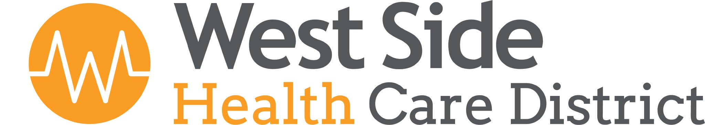

FINANCE COMMITTEE MEETING

Tuesday, May 25, 2021 at 12:00 pm

- CALL TO ORDER
The meeting of the Finance Committee of the West Side Health Care District convened on Tuesday
May 25, 2021, at 119 Adkisson Way Taft, CA. The meeting was called to order at 12:19 pm.
Those present were:

Eric Cooper – Board President
Virginia Miller – Board Secretary
Gerald Starr – Ryan Shultz
Robyn Melton – Clerk of the Board

2. PUBLIC INPUT - None

3. FINANCIAL REVIEW-
CPA, Kelly Hohenbrink joined the meeting via telephone. The April 2021 Financial
Reports were reviewed. Net position as of April 30, 2021 was $16,841,146.00. After further details
were discussed, Ginny Miller made a motion to accept the Financial Statements for presentation to
the Board. Seconded by Eric Cooper, Motion carried.

The Committee reviewed and discussed the Fiscal Year 2021/2022 Proposed Budget.
The Committee made a motion to recommend the proposed 21/22 Budget, as presented to the
Board at the regular Board Meeting, scheduled for Thursday, May 27, 2021.

4. BOARD INPUT –
None

5. CLOSED SESSION
The Finance Committee did not enter into Closed Session.

6. ADJOURNMENT
Being no further business, the meeting was adjourned at 1:22 pm

Respectfully submitted:
Virginia Miller, Committee Member

